Lab #9 Interpolation
Adam Jaso
11/08/11
Interpolation of Data

Objective
The objective of this experiment is to use the numerical method of interpolation to produce an exact fit calculation to data points.

Procedure
The interpolation method uses a Taylor first order approximation of the function at N given points, to solve N equations for a single function. The procedure followed these steps:
- Declare the points to be interpolated.
- Calculate the exact points that these points model using the function “exact(xs)”.
- Calculate the points of this interpolation.
  - Calculate each interpolation point as a result of this equation. The function performing this calculation was named “p(x,xs,ys)” where x is the evaluation point, xs is an array of the x-points for interpolation, and ys is an array of the y-points for interpolation. The function performs an iterative summation. This calculation stores each calculated point in pair with its corresponding x value.
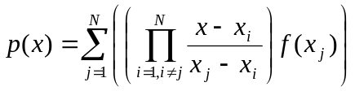
  - The product within the summation above was called “L(x,xs,j)”; it performs an iterative product skipping the element where i=j.
- Finally, create a plot of the values calculated from this interpolation, and print out a table of values where the first column is the x value, the second is the interpolated value, the third is the actual value, and the fourth is the absolute difference between the interpolated and actual values. In the results section, since the table is rather long, only the first ten values are presented as a sample.

Code / Results
***** INTERPOL.M CODE *****
function []=interpol()
%interpol.m
%This function interpolates the function f(x) = 1.5^x cos(2x);
Xs=0:1:5;
Ys=[1.0 -.6242 -1.4707 3.2406 -.7366 -6.3717];
xs=0:.01:5;
ys=exact(xs);

N=length(xs);
ps(N)=0;
for i=1:N
ps(i)=p(xs(i),Xs,Ys);
end

plot(Xs,Ys,'b+');
xlabel('x values');
ylabel('f(x)');
title({'Plot of the function f(x) = 1.5^x cos(2x)','with interpolated points'});

hold on;
plot(xs,ps,'r-');
plot(xs,ys,'g-');
set(legend('Interpolated Points','Interpolated Function: p(x)','Actual Function: f(x)'),'Location','SouthWest');

fprintf('x \tp(x) \ty(x) \t|p-y| \n--------\t--------\t--------\t--------\n');
for i=1:N
fprintf('%f\t%f\t%f\t%f\n',xs(i),ps(i),ys(i),abs(ps(i)-ys(i)));
end

end

function p=p(x,xs,ys)
N=length(xs);
p=0;
for j=1:N
p=p+L(x,xs,j)*ys(j);
end
end

function L=L(x,xs,j)
N=length(xs);
%fprintf('%d\n',N);
L=1;
for i=1:N
if i ~= j
L=L*(x-xs(i))/(xs(j)-xs(i));
end
end
end

function vs=exact(xs)
vs=1.5.^xs.*cos(2*xs);
end

***** INTERPOL.M RESULTS *****
>> interpol()
x p(x) y(x) |p-y|
-------- -------- -------- --------
0.000000 1.000000 1.000000 0.000000
0.010000 1.121242 1.003862 0.117379
0.020000 1.237083 1.007336 0.229748
0.030000 1.347628 1.010417 0.337211
0.040000 1.452977 1.013100 0.439876
0.050000 1.553230 1.015382 0.537848
0.060000 1.648487 1.017258 0.631229
0.070000 1.738846 1.018724 0.720123
0.080000 1.824405 1.019775 0.804630
0.090000 1.905260 1.020409 0.884851
0.100000 1.981508 1.020621 0.960886
... ... ... ...

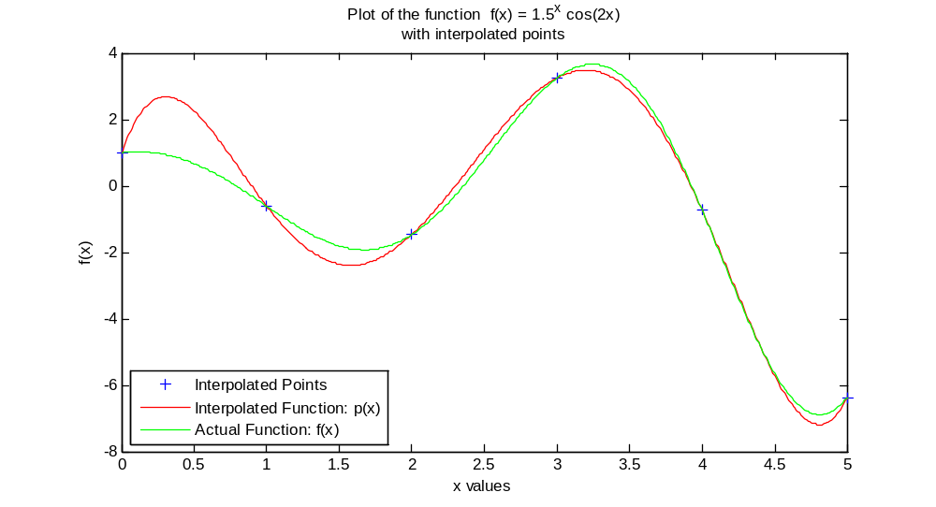

Observations
While the fit of the interpolation to the actual curve was roughly satisfactory, the difference was nevertheless quite significant as can be seen by the plot. A spline may better fit these data points.

